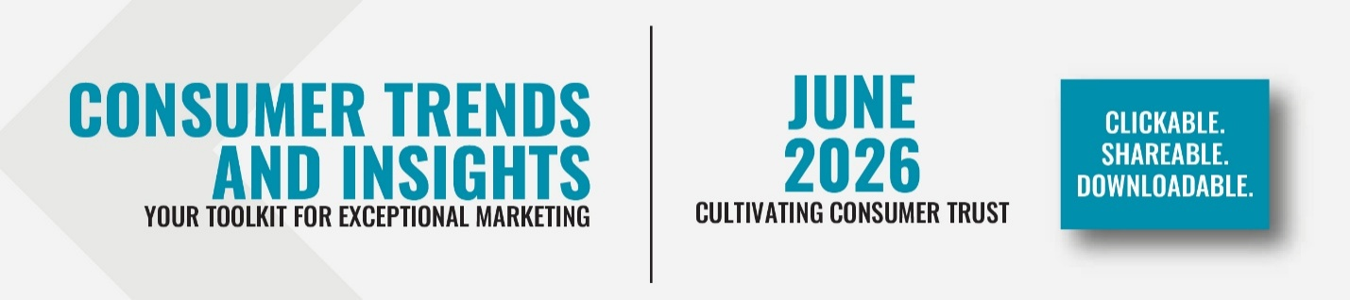

Welcome to the Center for California Real Estate's (CCRE) member marketing toolkit of slides, social posts and video exploring consumer issues in residential real estate. Download these data-driven tools to enhance your marketing plans and spark conversations in your spheres of influence.
Consumer trust is evolving. In an environment shaped by economic uncertainty, information overload, and declining confidence in institutions, consumers are approaching major financial decisions with greater caution and higher expectations.
Today's clients are looking for more than expertise. They want transparency, authenticity, responsiveness, and to work with professionals who understand their goals and concerns.
This toolkit equips you with data-driven insights, practical takeaways, and consumer resources to help you understand changing dynamics of trust and build lasting confidence with today's homebuyers and sellers.

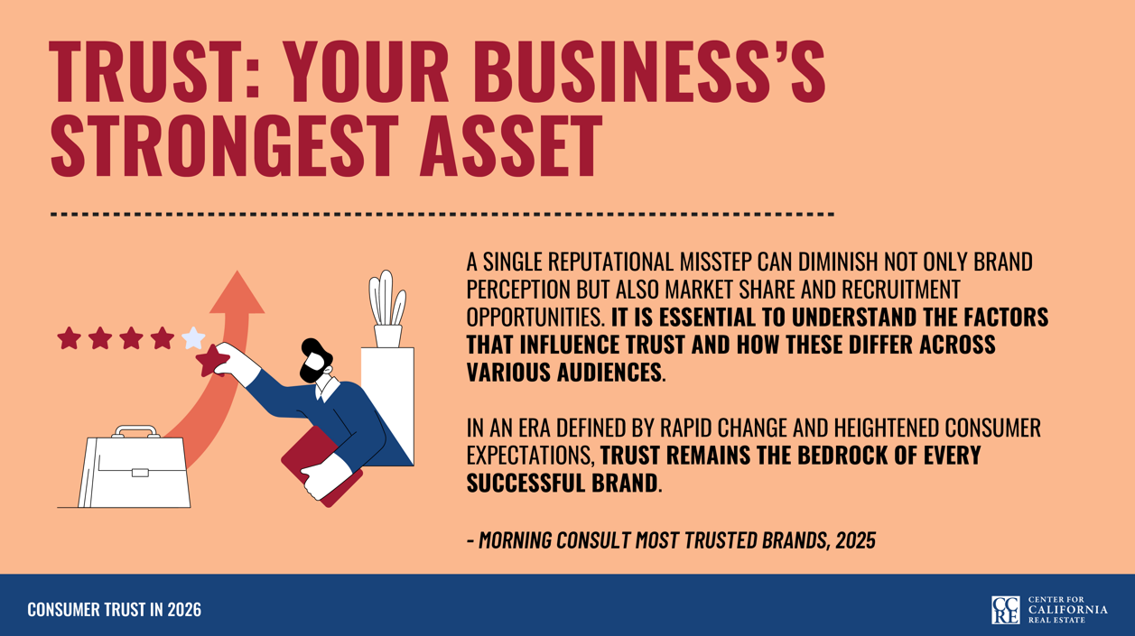

SLIDE DECK: Download and insert these slides into a listing presentation or view them as a slide show in your next office meeting.
​​​​

 |  |  | SOCIAL MEDIA POSTS: Download and share these social posts to help your clients achieve their goals.
 | CONSUMER GUIDE:  Share these easy, effective methods of maximizing the REALTOR®-client relationship, featuring space for your contact info. |  | 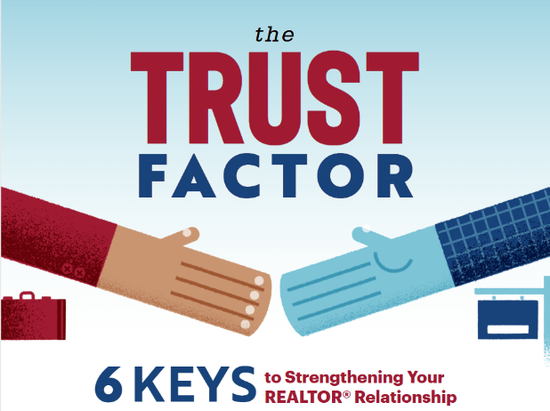
 |  |  | CONSUMER VIDEO: ​​​  Share this three-minute video, 6 Keys to Strengthening Your REALTOR® Relationship.

 | TOP 5 TAKEAWAYS: Key insights to help you guide first-time buyers with clarity and confidence.
 |  |  | Today’s consumers expect REALTORS® to earn trust through transparency, responsiveness, authenticity, and empathy.
 |  |  | Consumers are increasingly skeptical of brands and institutions, often suspecting they are being lied to by leaders and the media. Creating trust through personal relationships and credibility is more important than ever.
 |  |  | Consumers trust small businesses more than large ones. REALTORS® have a unique opportunity to capitalize on this by actively educating clients and addressing pain points throughout the transaction process.
 |  |  | Setting clear expectations around compensation, communication, and risk management at the beginning of the client-REALTOR® relationship can help prevent misunderstandings and achieve desired outcomes.
 |  |  | While some AI tools can support the home search, consumers should be wary of results from AI models and rely on their REALTOR® for accurate, real-time insights and transaction expertise.

Missed an issue? Visit the Consumer Trends and Insights archive on the CCRE website.
Disclaimer: Use of the materials contained in CCRE Consumer Trends and Insights must include proper attribution to Kantar, LLC. Attribution is already built into the downloadable tools, and members are asked not to remove or alter these credits when sharing with clients or the public.

